Introduction

The telecoms churn dataset consists of 512 observations of unique customers. This data contains recorded information such as a categorical variable under the payment method used column, a continuous variable under the monthly charge’s column, do they live with a partner indicated with a yes or no, what kind of internet service do they have recorded as a categorical variable, gender denoted by a 1 or 0, customer id and if they stayed with the provider or not indicated by a binary value under the churn column.

Table 1: Telecoms churn data sample

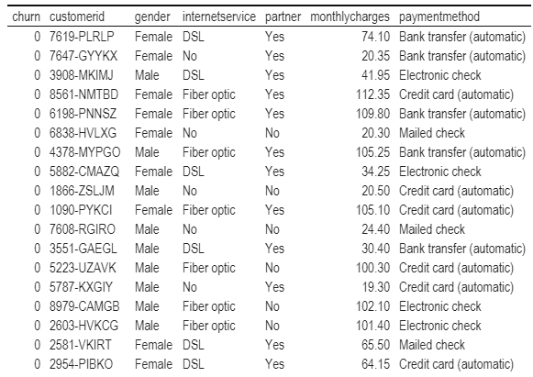

The goal of this report is to synthesise a model that could provide a probability for a customer who is male, living with a partner, has monthly charges equal to 70, has fibre optic internet and uses a credit card as a payment method. Along with this provide a report of the relationship between each predictor and the response churn. There are 2 more versions of the dataset described above, one only contains users that have internet access whereas the other has those that don’t. Users without internet make up 100 of the 512 observations and users with internet make up the other 412 observations. The goal here is to investigate if there is a separate trend between these two groups. A density plot was used to split users with and without internet based on monthly charges, as seen in Figures 1, 2 and 3. Internet users seem to also have two separate groups of customers divided by monthlycharges indicatd by the bimodal distribution.

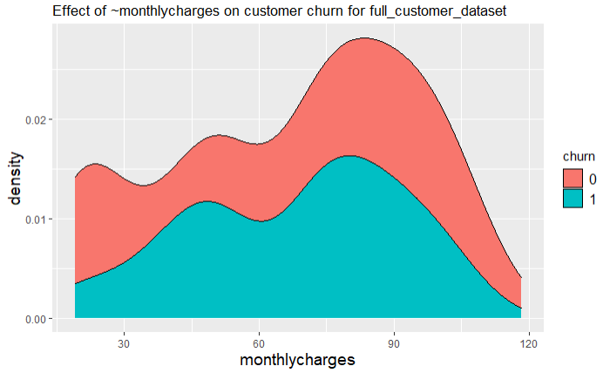

Figure 1: Density graph of monthly charges for all users

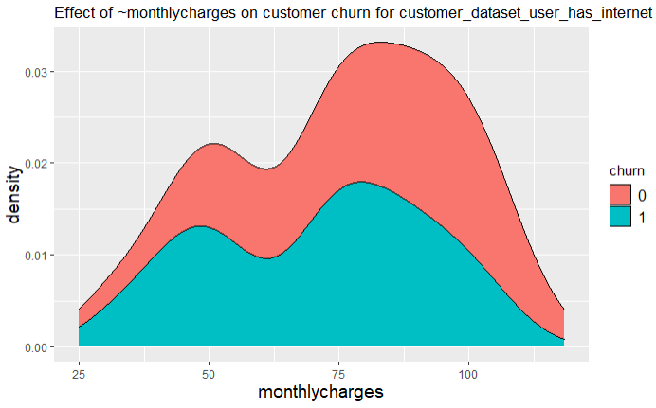 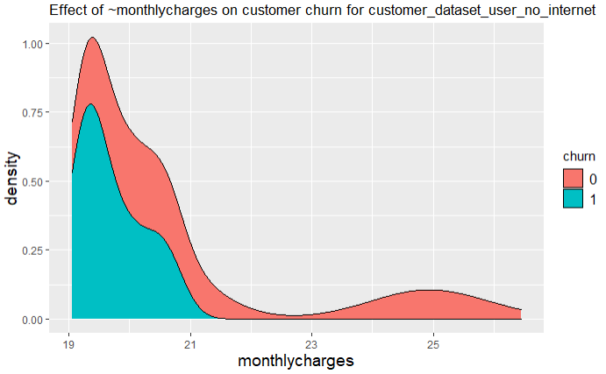

Figure 2: Density graph of monthly charges, users with internet Figure 3: Density graph of monthly charges, users without internet

Table 2 presents the values and distribution of values per column without flooding the report with a plethora of plots and graphs. 16.6 % of customers in this data set have chosen to leave. There is a ~5% difference between customer genders, 55.66% being men, 44.34 being women. The most popular internet offering is fibre optic at 46.88 % then 19.53% of users don’t have either DSL or fibre optic. There is an even split of users that live with and without a partner at 50.59 and 49.41 respectively. The preferred payment method is electronic check at 35.35%.

Table 2: Unique values and % of representation in the original telecoms churn data set

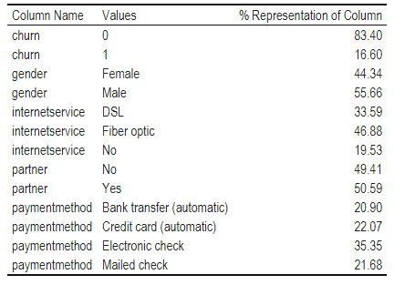

Table 3: Unique values, % of representation, users with internet Table 4: Unique values, % of representation, users without internet

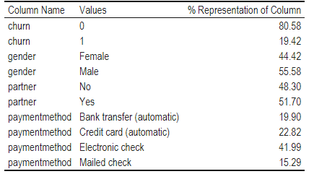 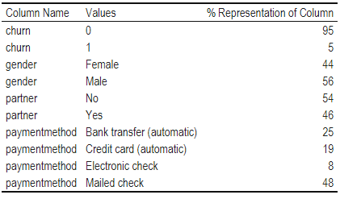

Model 1

A full interaction general linear model was fitted using *gender, internetservice, partner, monthlycharges, paymentmethod* as factors with churn as the response.

The model was:

$$y_{i}= β_{0}+ β_{1}\left(δ_{i,male}\right)+ β_{2}\left(δ_{i, No}\right)+β_{3}\left(δ_{i, FIber optic}\right) + β_{4}\left(δ_{i, No}\right)+ β_{5}\left(δ_{i, Electronic check}\right)+ β_{6}\left(δ_{i, Credit card (automatic)}\right)+ β_{7}\left(δ_{i, Mailed check}\right) +β_{8}\left(δ_{i,male}* δ_{i,No }* δ_{i,No }*δ_{i,Electronic check }\right) ++β_{9}\left(δ_{i,male}* δ_{i,Fiber optic }* δ_{i,No }*δ_{i,Electronic check }\right) +β_{10}\left(δ_{i,male}* δ_{i,DSL }* δ_{i,No }* δ_{i,Electronic check }\right) +β_{11}\left(δ_{i,male}* δ_{i,Fiber optic }* δ_{i,Yes }* δ_{i,Electronic check }\right)+β_{12}\left(δ_{i,male}* δ_{i,Fiber optic }* δ_{i,No }* δ_{i,Electronic check }\right)+β_{13}\left(δ_{i,male}* δ_{i,DSL }* δ_{i,Yes }* δ_{i,Electronic check }\right)+β_{14}\left(δ_{i,male}* δ_{i,DSL }* δ_{i,No }* δ_{i,Electronic check }\right)+β_{15}\left(δ_{i,male}* δ_{i,No }* δ_{i,No }* δ_{i,Bank transfer (automatic) }\right)+β_{16}\left(δ_{i,male}* δ_{i,No }* δ_{i,No }* δ_{i,Bank transfer (automatic) }\right)+β_{17}\left(δ_{i,male}* δ_{i,No }* δ_{i,No }* δ_{i,Bank transfer (automatic) }\right)+β_{18}\left(δ_{i,male}* δ_{i,No }* δ_{i,No }* δ_{i,Bank transfer (automatic) }\right) + ϵ_{i}$$

Where $y_{i}$ is the live carbon fibre strength for the sample $i_{ }$, $β_{1}\left(δ_{i,low}\right)$ = 1 if the sample was synthesised at low temperature, 0 otherwise, repeat for all temperatures. Where $β_{3}\left(γ_{i, a}\right)$ = 1 if additive A was used, 0 otherwise. Then to check for an interaction between temperature and additive used $β_{6}\left(δ_{i,high}* γ_{i, a}\right)$ = 1 if both temperature = High and additive = A, 0 otherwise, this is repeated for each combination of temperature and additive.

This hypothesis was tested using the standard formulation for general linear hypothesis, results in Table 5*.* Using the anova( ) function in R with the F-statistic as the test, *internetservice* had a p-value of 0.001 and a f-value of 7.3, *partner* had a p-value of 9.600e-05 with a f-value of 15.47, *monthlycharges* had a p-value of 2.631e-08 and a f-value of 6.6, *paymentmethod* had a p-value of 0.0002 and a f-value of 6.6.

There were two interactions found using the anova( ) function, *partner* and *monthlycharges* yielded a p-value of 0.043 with a f-value of 4.1.The second interaction is between *monthlycharges* and *paymentmethod* with a p-value of 0.00946 and a f-value of 3.8.

When using the drop1( ) function in R using the F-statistic as a test there are 2 similar interactions, which were *monthlycharges* and *paymentmethod* electronic check with a p-value of 0.0024 the other being between *partner* and *monthlycharges* with a p-value of 0.0429.

Upon examining the summary of the model, *paymentmethod* using electric check had a p-value of 0.0009, having a partner yielded a p-value of 0.04. An interaction between having a partner while using electronic check as a payment method had a p-value of 0.008, the p-value for the intercept of this model is 0.8713. As one could expect *monthlycharges* had a p-value of 0.0059 with a f-value of 8.531, the interaction between *monthlycharges* and *paymentmethod* yielded a p-value of 0.0078. All other values were not statistically significant to include in the report.

When using the two sanitised datasets, the above statistics were found to be statistically significant.

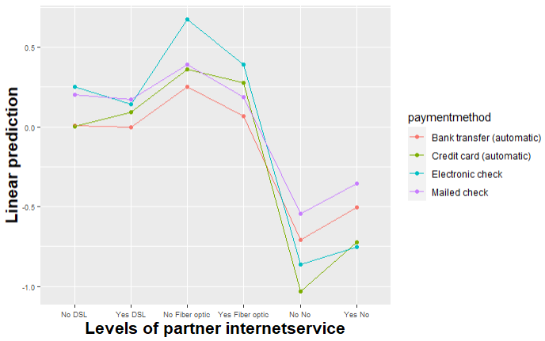

Figure 4: Interaction plot for model 1 of partner status and internet service used

Conclusion

The goal of this analysis was to see the probability of a specific client leaving meanwhile reviewing any predictors and possible interactions between them.

Based on Table 4 ‘users without internet’ only 5% (5 users) of 100 customers contributed to churn in said group, meanwhile in Table 3 ‘users with internet’ almost 20% (80 users) of 412 customers contributed to churn in said group. Based on data gathered in Tables 2,3 and 4 customers without internet contribute 0.0097% (5/512) to total customer churn which is 16.6%, whereas the latter 15.6% (80/512) of total customer churn (16.6%).

When trying to predict the probability whether a male living with a partner, who’s monthly charges are 70 for fiber optic internet paid for with a credit card will leave the telecommunication provider it was found that the probability is 28% using the general linear model documented under model 1 with an upper bound of 0.51 and lower bound 0.05.

Table 5: Lower and upper confidence intervals for model 1 predictions on requested customer profile



It has been found that both monthly charges were the highest predictor of churn with a p-value of 0.0009, however when adjusting monthly charges for the specified user the higher the cost the lower the probability of them leaving, with an inverse effect as costs went down, albeit that could be a correlation. Based on the interaction plot which didn’t include monthly charges, living without a partner while paying for fiber optic internet was the highest predictor of churn for all payment methods, meanwhile there was very little difference on this combination when fiber optic was swapped out for DSL in conjunction with payment method. This could infer that customer who pay for their internet services with electronic checks would have less use for it and/or income to pay for fiber optic internet, having said that.

Living with a partner and monthly charges had an interaction effect with a p-value of 0.042 which would

Code sample